**Getting Started with Argon Base**

**Overview**

With Argon Base, you can learn about robotics, electronics, mechanics and software. Argon Base is a tiny computer on wheels. It comes with a number of project examples you can easily replicate, and it is a powerful robotics platform that you can hack to perform all sorts of tasks.

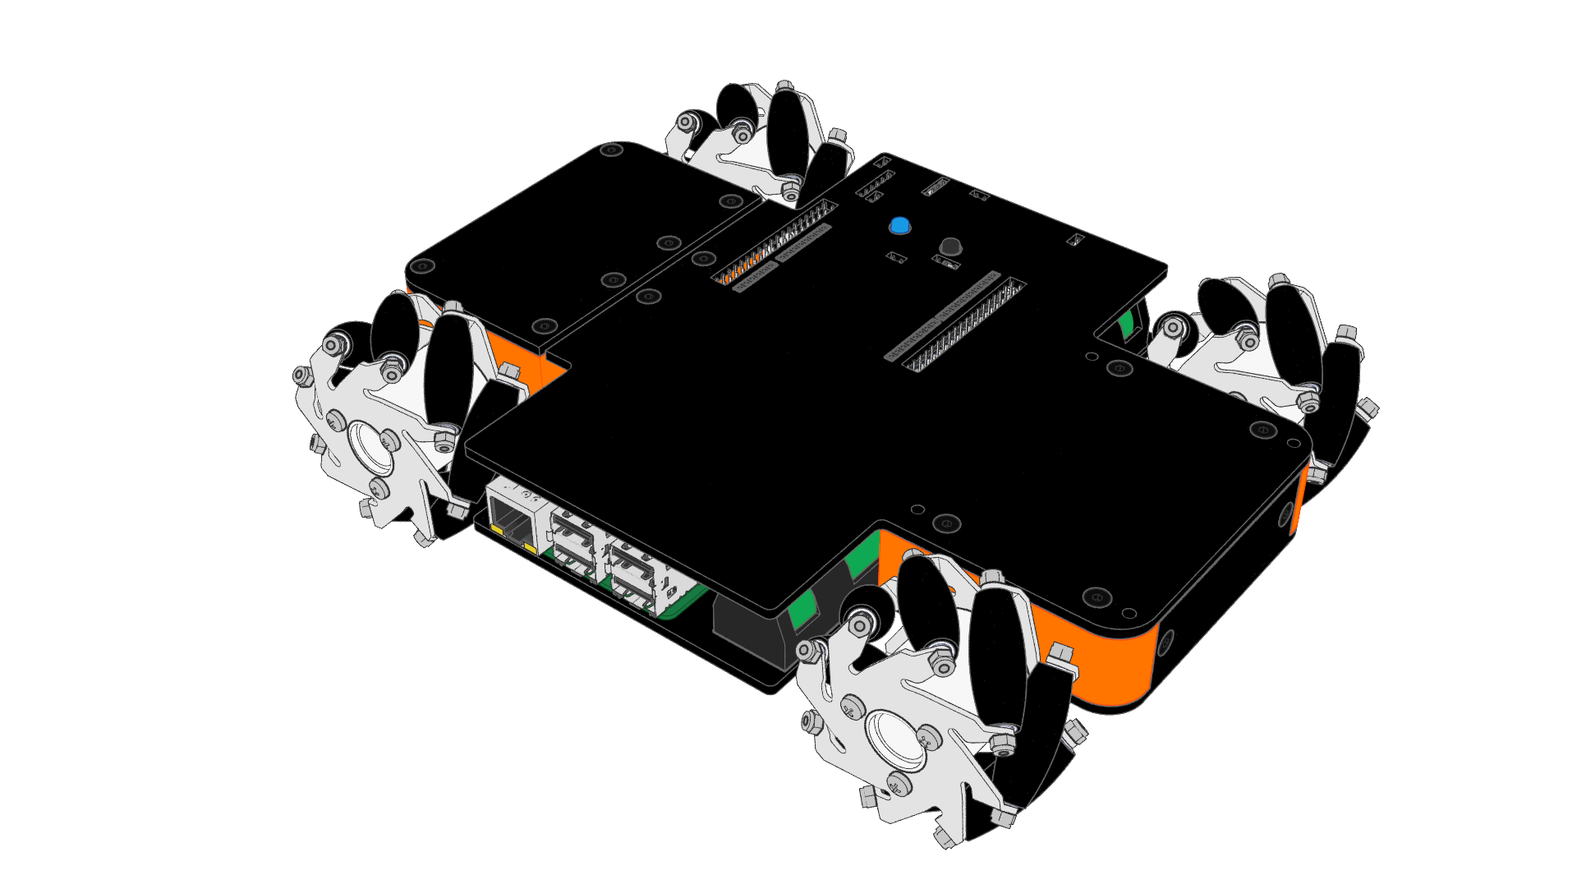

Argon Base comes with four motors with encoders which are attached to mecanum wheels and four motor drivers with current sense capability. You can control these components and actuators through Argon library.

There are three different boards on Argon Base; a Nucleo-F446RE control board, a Raspberry Pi 3 and a power supply board. The GPIO pins of Raspberry Pi 3 and Nucleo-F446RE can be used to attach many different types of sensors and actuators.

**Technical Specifications**

There are four encoder gear motors, four motor drivers and three different boards on Argon Base; a Nucleo-F446RE control board, a Raspberry Pi 3 and a power supply board.

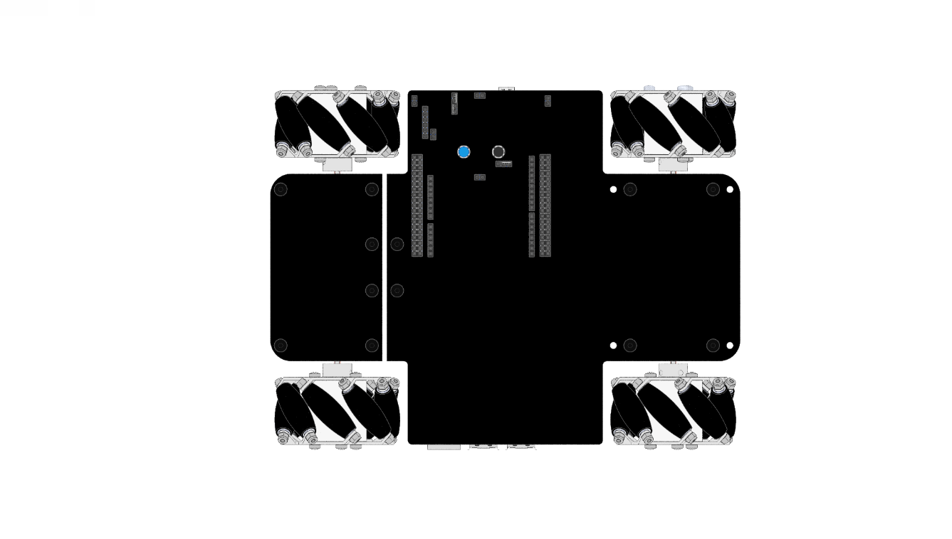**Argon Base Dimensions**

|  |  |
| --- | --- |
| **Width** | **123 mm** |
| **Length** | **123 mm** |
| **Height** | **123 mm** |
| **Net Weight** | **123 mm** |
| **Load Capacity** | **123 mm** |
| **Lorem Ipsum** | **123 mm** |
| **Lorem Ipsum** | **123 mm** |
| **Lorem Ipsum** | **123 mm** |
| **Lorem Ipsum** | **123 mm** |

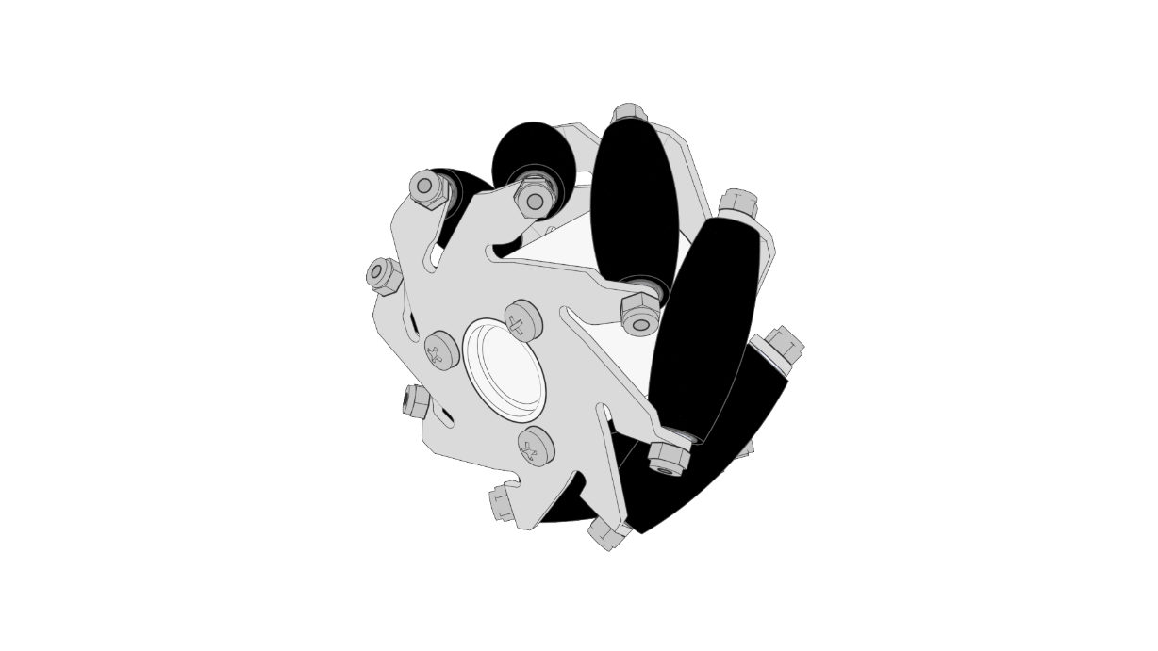**Mecanum Wheel Dimensions**

|  |  |
| --- | --- |
| **Diameter** | **60 mm** |
| **Width** | **31 mm** |
| **Number of Rollers** | **8** |
| **Number of Plates** | **2** |
| **Body Material** | **Aluminum Alloy** |
| **Roller Material** | **PP+PE** |
| **Length of Roller** | **30 mm** |
| **Net Weight** | **86 g** |
| **Load Capacity** | **3 kg** |

**Geared DC Motor with Encoder Specs**

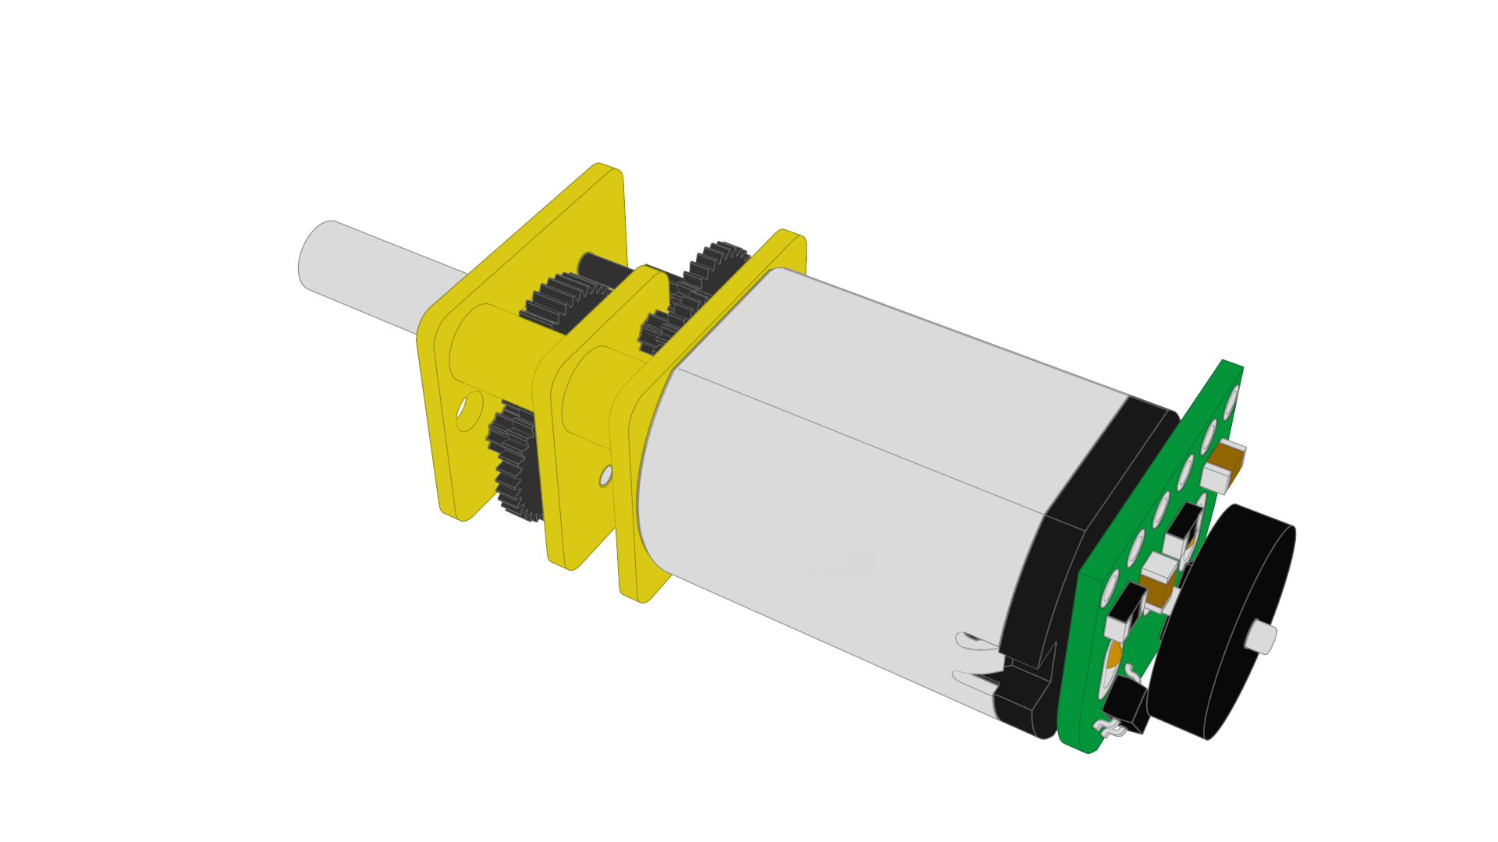

**Geared DC Motor**

|  |  |
| --- | --- |
| **Size** | **10 x 12 x 40 mm** |
| **Weight** | **9.5 g** |
| **Shaft Diameter** | **3mm D shaft** |
| **Rated Voltage** | **12 V** |
| **Motor Type** | **High-power carbon brushed** |
| **Free-run Current (12V)** | **100 mA** |
| **Stall Current (12V)** | **800 mA** |
| **No-Load Speed (12V)** | **320 RPM** |
| **Stall Torque (12V)** | **30 oz-in** |
| **Gear Ratio** | **≈100.37:1** |

**Magnetic Encoder Specs**

|  |  |
| --- | --- |
| **Size** | **10.6 x 11.6 mm** |
| **Weight** | **0.5 g** |
| **Minimum Operating Voltage** | **2.7 V** |
| **Maximum Operating Voltage** | **18 V** |
| **Encoder Type** | **Magnetic** |
| **Count per Revolution** | **3 CPR** |
| **Quadrature Resolution** | **12 CPR** |

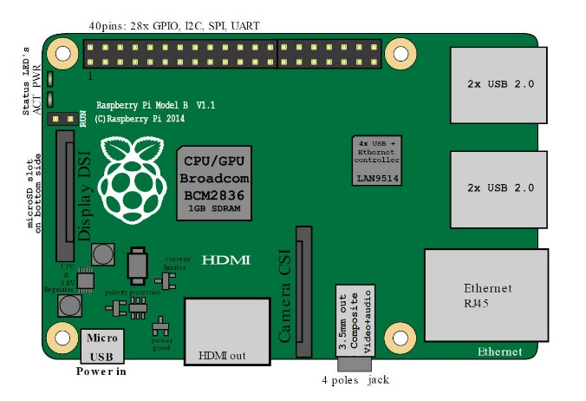**Controller Board Summary**

|  |  |
| --- | --- |
| **Processor** | **lorem ipsum** |
| **RAM** | **lorem ipsum** |
| **Network** | **lorem ipsum** |
| **GPIO** | **lorem ipsum** |
| **Video** | **lorem ipsum** |
|  |  |
|  |  |

**Raspberry Pi 3 Summary**

|  |  |
| --- | --- |
| **Processor** | **lorem ipsum** |
| **RAM** | **lorem ipsum** |
| **Network** | **lorem ipsum** |
| **GPIO** | **lorem ipsum** |
| **Video** | **lorem ipsum** |
| **Video** | **lorem ipsum** |
| **Video** | **lorem ipsum** |

**Documentation**

**Schematics**

**Power**

**Input and Output**

**Control Board Pin Mapping**

**Raspberry Pi 3 Pin Mapping**

**Communication**

**Programming**